# Lab: Data Types: Numeral Types and Type Conversion

Problems for exercises and homework for the [“Programming Fundamentals” course @ SoftUni](https://softuni.bg/courses/programming-fundamentals).

You can check your solutions here: <https://judge.softuni.bg/Contests/171/Data-Types-and-Variables-Lab>.

# Integer and Real Numbers

## Time Since Birthday

Write program to enter an integer number of **years** and convert it to **days**, **hours** and **minutes**.

### Examples

|  |  |
| --- | --- |
| **Input** | **Output** |
| 20 | 20 years = 7300 days = 175200 hours = 10512000 minutes. |
| 14 | 14 years = 5110 days = 122640 hours = 7358400 minutes. |

### Hints

* Use appropriate data type to fit the result after each data conversion.
* Assume that every year has 365 days.

### Solution

You might help yourself with the code below:

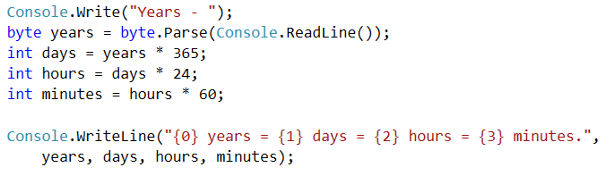

## Circle Perimeter (12 Digits Precision)

Write program to enter a radius r (real number) and **print the perimeter** of a circle with exactly **12 digits** after the decimal point. Use data type of **enough precision** to hold the results.

### Examples

|  |  |  |  |  |
| --- | --- | --- | --- | --- |
| **Input** | **Output** |  | **Input** | **Output** |
| 0.05 | 0.314159265359 |  | 1.2 | 7.539822368616 |

### Hints

* You might use the data type double. It has precision of 15-16 digits.
* To print the output with exactly 12 digits after the decimal point, you might use the following code:



## Exact Product of Real Numbers

Write program to enter n numbers and calculate and print their **exact product** (without rounding).

### Examples

|  |  |  |  |  |
| --- | --- | --- | --- | --- |
| **Input** | **Output** |  | **Input** | **Output** |
| 3  1000000000000000000  5  10 | 50000000000000000000 |  | 2  0.00000000003  333333333333.3 | 9.999999999999 |

### Hints

* If you use types like float or double, the result will lose some of its precision. Also it might be printed in scientific notation.
* You might use the decimal data type which holds real numbers with high precision with less loss.
* Note that decimal numbers sometimes hold the unneeded zeroes after the decimal point, so 0m is different than 0.0m and 0.00000m.

# Type Conversion

## Transport

Calculate how many courses will be needed to **transport n persons** by using 3 vehicles of **capacity 4, 8 and 12** respectively. The input holds one line: the **number of people n**. The vehicles **can** travel at the same time.

### Examples

|  |  |  |
| --- | --- | --- |
| **Input** | **Output** | **Comments** |
| 50 | 3 | 2 course * 24 persons + 1 course * 2 person |
| 24 | 1 | All the persons fit inside in one total course of the vehicles.  Only one course is needed. |
| 150 | 7 | 150 / (4 + 8 + 12) = 6.25 => 7 courses  6 courses * 24 people (4 + 8 + 12) + 1 course * 6 people |

### Hints

* You should **divide** n **by** the sum of all the cars’ capacity. This gives you the number of full courses (e.g. 25 / 24 = 1.04).
* If n does not divide without a remainder, you will need one additional partially full course (e.g. 25 % 24 = 1).
* Another approach is to round up n / (4+8+12) to the nearest integer (ceiling), e.g. 25/24 = 1.04 🡪 rounds up to 2.
* Sample code for the round-up calculation:

